M3U2PLEX SETUP

1. Close Plex completely
2. Extract M3U2PLEX zip file to your downloads folder
3. Make Sure That Telly is also in your downloads folder or M3U2PLEX Will Not Work
4. Run M3U2PLEX.exe
5. INSERT Your URL
6. Keep The Program Open and let it run for Plex Live DVR to Work
7. Open Plex and go to Settings, Server, Live TV & DVR and select SET UP PLEX DVR
8. Select the ENTER YOUR ADDRESS MANUALLY drop down.
9. For Device Address put in localhost:7575 and click the tab to the right of it that says connect and then select the continue tab on the lower right.
10. It will bring you to another screen and you will see all of your channels displayed make sure the cable tab says cable and the country says United States and click continue.
11. For Postal code put in 10001, it will load a epg make sure you select DIRECTV New York.
12. Map the rest of the channels to the EPG the channel numbers are listed to the left of the channel name all you have to do is match them correctly they are in numerical order.
13. Select continue and now you have a full fledge IPTV link to your Plex.

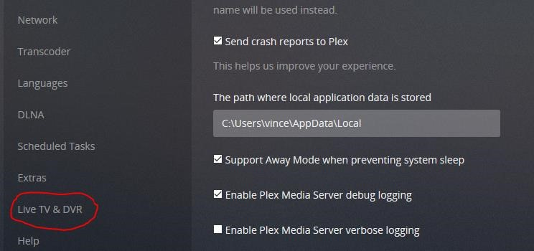

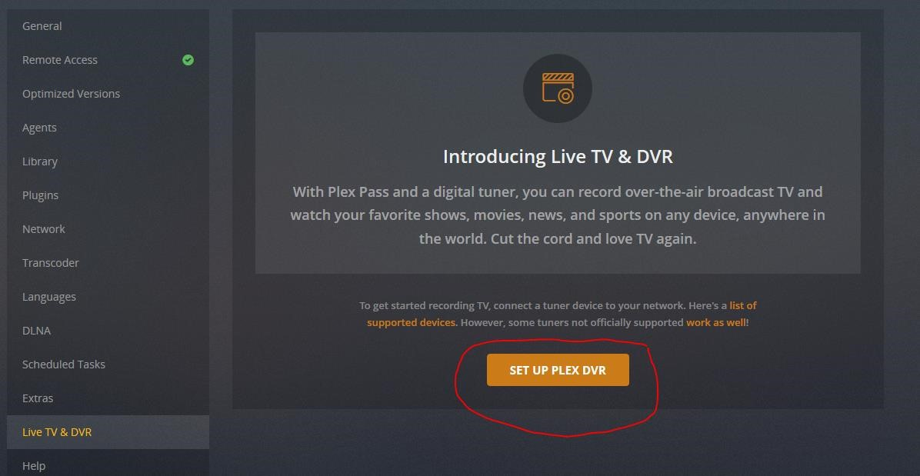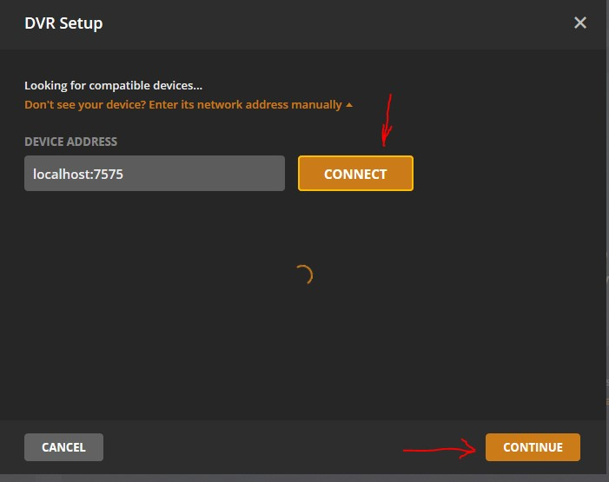

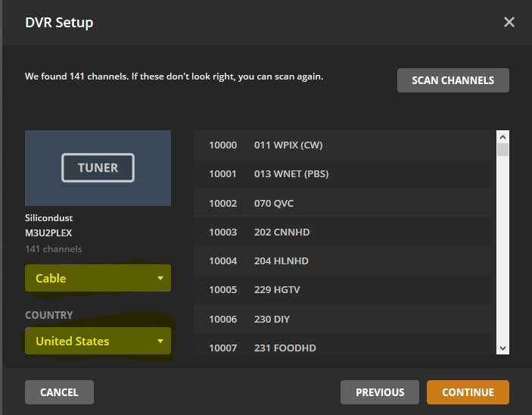

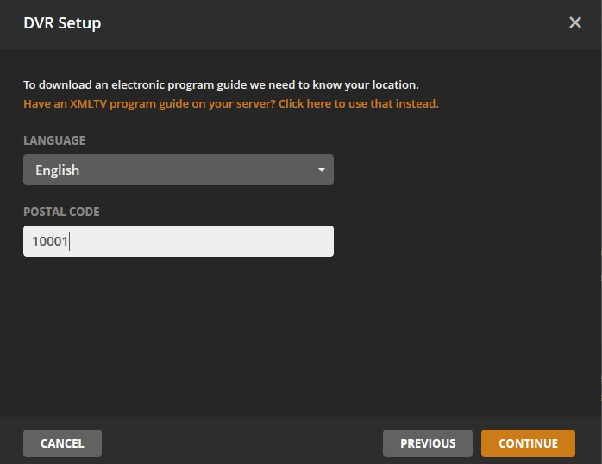

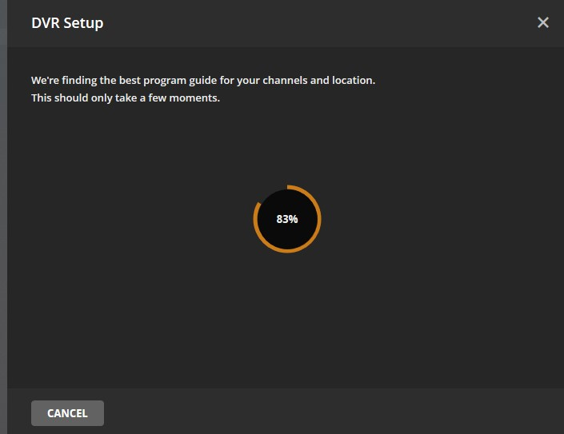

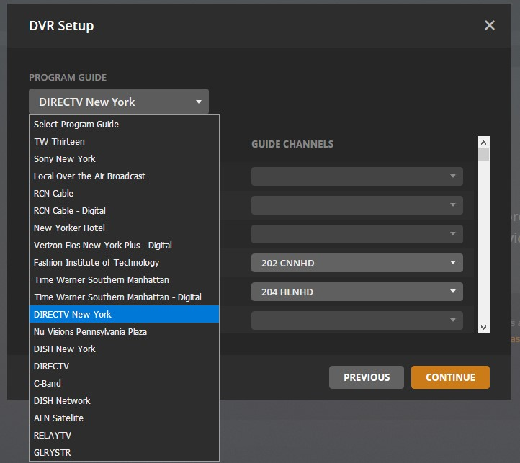

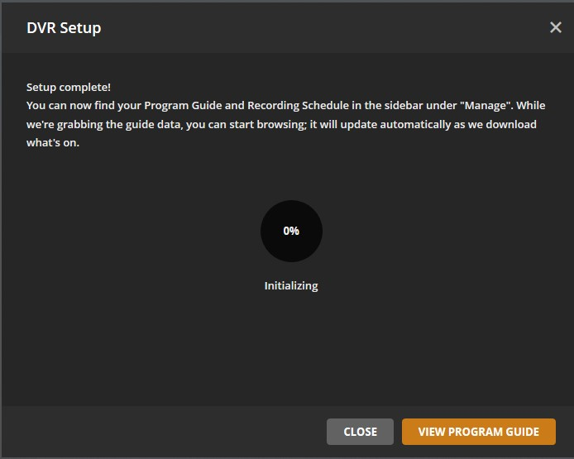

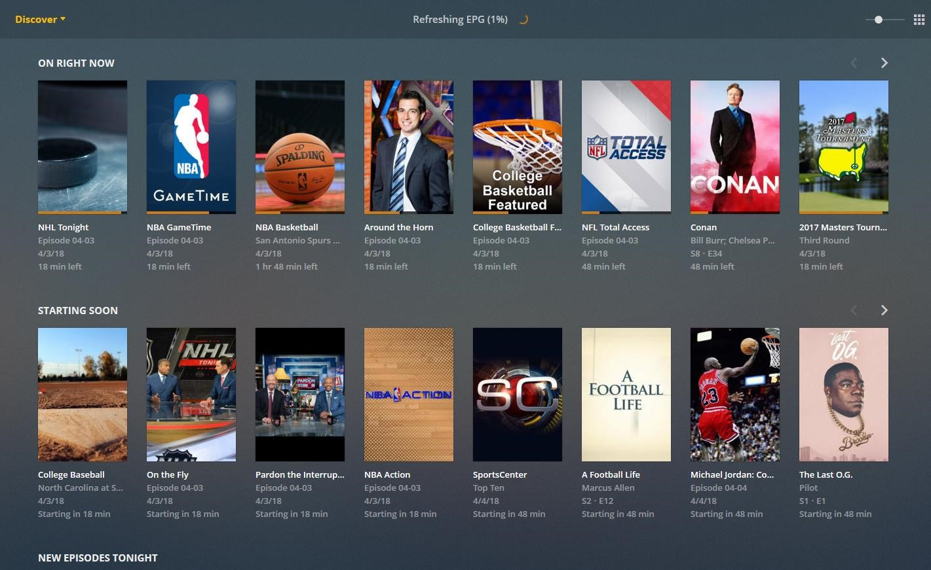

CREATED BY M3U2PLEX 2018